Part 1 – Creating Tables

1. User Table

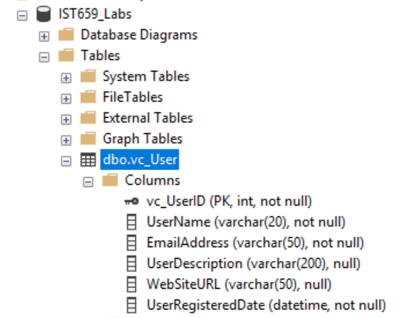

1. User Login Table

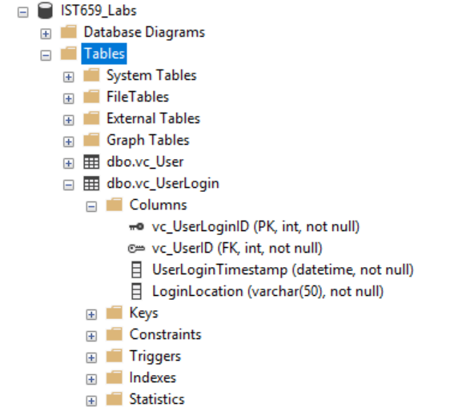

1. User records

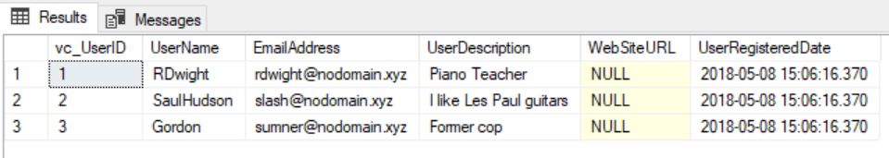

1. User Tables

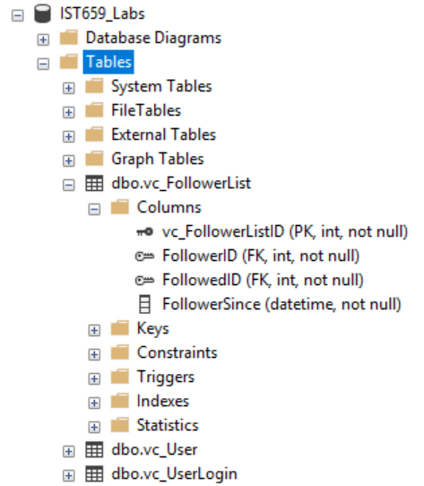

Part 2 – The Rest of the Tables

1. VidCast tables

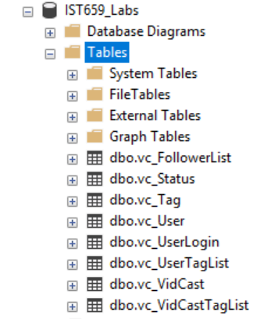

1. SQL Query Code
2. /*
3. Author: Martin Alonso
4. Course: IST659 M407
5. Term: April 2018
6. */
7. --Creating the User table
8. CREATE TABLE vc_User (
9. --Columns for the User table
10. vc_UserID int identity,
11. UserName varchar(20) not null,
12. EmailAddress varchar(50) not null,
13. UserDescription varchar(200),
14. WebSiteURL varchar(50),
15. UserRegisteredDate datetime not null default GetDate(),
16. --Constraints on the User Table
17. CONSTRAINT PK_vc_User PRIMARY KEY (vc_UserID),
18. CONSTRAINT U1_vc_User UNIQUE(UserName),
19. CONSTRAINT U2_vc_User UNIQUE(EmailAddress)
20. )
21. --End Creating the User table
22. --Creating the UserLogin table
23. CREATE TABLE vc_UserLogin (
24. --Columns for the UserLogin table
25. vc_UserLoginID int identity,
26. vc_UserID int not null,
27. UserLoginTimestamp datetime not null default GetDate(),
28. LoginLocation varchar(50) not null,
29. --Constraints on the User Login Table
30. CONSTRAINT PK_vc_UserLogin PRIMARY KEY (vc_UserLoginID),
31. CONSTRAINT FK1_vc_UserLogin FOREIGN KEY (vc_UserID) REFERENCES vc_User(vc_UserID)
32. )
33. --End Creating the UserLogin table
34. --Adding Data to the user table
35. INSERT INTO vc_User(UserName, EmailAddress, UserDescription)
36. VALUES
37. ('RDwight', 'rdwight@nodomain.xyz', 'Piano Teacher'),
38. ('SaulHudson', 'slash@nodomain.xyz', 'I like Les Paul guitars'),
39. ('Gordon', 'sumner@nodomain.xyz', 'Former cop')
40. SELECT * FROM vc_User
41. --Creating the Follower List table
42. CREATE TABLE vc_FollowerList (
43. --Columns for the Follower List table
44. vc_FollowerListID int identity,
45. FollowerID int not null,
46. FollowedID int not null,
47. FollowerSince datetime not null,
48. --Constraints on the Follower List table
49. CONSTRAINT PK_vc_FollowerList PRIMARY KEY (vc_FollowerListID),
50. CONSTRAINT U1_vc_FollowerList UNIQUE (FollowerID, FollowedID),
51. CONSTRAINT FK1_vc_FollowerList FOREIGN KEY (FollowerID) REFERENCES vc_User(vc_UserID),
52. CONSTRAINT FK2_vc_FollowerList FOREIGN KEY (FollowedID) REFERENCES vc_User(vc_UserID)
53. )
54. --End creating the Follower List table
55. --Creating the Tag table
56. CREATE TABLE vc_Tag (
57. --Columns for the Tag table
58. vc_TagID int identity,
59. TagText varchar(20) not null,
60. TagDescription varchar(100)
61. --Constraints on the Tag table
62. CONSTRAINT PK_vc_Tag PRIMARY KEY (vc_TagID),
63. CONSTRAINT U1_vc_Tag UNIQUE (TagText)
64. )
65. --End creating the Tag table
66. --Creating the Status table
67. CREATE TABLE vc_Status (
68. --Columns for the Status table
69. vc_StatusID int identity,
70. StatusText varchar(20)
71. --Constraints on the Status table
72. CONSTRAINT PK_vc_Status PRIMARY KEY (vc_StatusID),
73. CONSTRAINT U1_vc_Status UNIQUE (StatusText)
74. )
75. --End creating the Status table
76. --Creating the VidCast table
77. CREATE TABLE vc_VidCast (
78. --Columns for the VidCast table
79. vc_VidCastID int identity,
80. VidCastTitle varchar(50) not null,
81. StartDateTime datetime,
82. EndDateTime datetime,
83. ScheduledDurationMinutes int,
84. RecordingURL varchar(50),
85. vc_UserID int not null,
86. vc_StatusID int not null
87. --Constraints on the VidCast table
88. CONSTRAINT PK_vc_VidCast PRIMARY KEY (vc_VidCastID),
89. CONSTRAINT FK1_vc_VidCast FOREIGN KEY (vc_UserID) REFERENCES vc_User(vc_UserID),
90. CONSTRAINT FK2_vc_VidCast FOREIGN KEY (vc_StatusID) REFERENCES vc_Status(vc_StatusID)
91. )
92. --End creating the VidCast table
93. --Creating the VidCastTagList table
94. CREATE TABLE vc_VidCastTagList (
95. --Columns for the VidCastTagList table
96. vc_VidCastTagListID int identity,
97. vc_TagID int not null,
98. vc_VidCastID int not null
99. --Constraints on the VidCastTagList table
100. CONSTRAINT PK_vc_VidCastTagList PRIMARY KEY (vc_VidCastTagListID),
101. CONSTRAINT U1_vc_VidCastTagList UNIQUE (vc_TagID, vc_VidCastID),
102. CONSTRAINT FK1_vc_VidCastTagList FOREIGN KEY (vc_TagID) REFERENCES vc_Tag(vc_TagID),
103. CONSTRAINT FK2_vc_VidCastTagList FOREIGN KEY (vc_VidCastID) REFERENCES vc_VidCast(vc_VidCastID)
104. )
105. --End creating the VidCastTagList table
106. --Creating the UserTagList table
107. CREATE TABLE vc_UserTagList (
108. --Columns for the UserTagList table
109. vc_UserTagListID int identity,
110. vc_TagID int not null,
111. vc_UserID int not null
112. --Constraints on the UserTagList table
113. CONSTRAINT PK_vc_UserTagList PRIMARY KEY (vc_UserTagListID),
114. CONSTRAINT U1_vc_UserTagList UNIQUE (vc_TagID, vc_UserID),
115. CONSTRAINT FK1_vc_UserTagList FOREIGN KEY (vc_TagID) REFERENCES vc_Tag(vc_TagID),
116. CONSTRAINT FK2_vc_UserTagList FOREIGN KEY (vc_UserID) REFERENCES vc_User(vc_UserID)
117. )
118. --End creating the VidCastTagList table